|  |  |  |  |
| --- | --- | --- | --- |
| **CS102** | **Fall 2020/21** | Project Group | 1D |
| Instructor: | **Uğur Güdükbay** |
| Assistant: | Sinan Sonlu |

|  |  |  |
| --- | --- | --- |
| **Criteria** | **TA/Grader** | **Instructor** |
| Presentation |  |  |
|  |  |  |
|  |  |  |
|  |  |  |
| Overall |  |  |

~ Sustainibility Coach ~

SavioursOfTheGreenWorld

Batuhan Balaban 21703122 | Berkay Yiğit 21702109 | Murat Ertan 22003067 | Selman Eldeniz 22003385 | Özgür Göker 22102317

|  |
| --- |
| UI Design Report  ( Volume 2 )  3 December 2022 |

# Introduction

The UI design consists of pages designed by different group members. There is login –sign-up pages, achievements page, profile page, forum page and news page. These pages shared here are not some graphical pictures that are drawn in a drawing environment. They show actual java swing library layouts designed using NetBeans. Therefore, these pages are actually part of the project in progress. These are not at their final forms and they will be developed further. Also, we preferred to implement the project for PC because we wanted to utilize CS 102 course material instead of some external development studio.

There is a menu bar above every page except for login and sign in pages. That way, the user navigates through the pages. Other details are explained in each of the following sections.

# Details

## Login – Sign Up pages

The first page that the users will encounter when they enter the site is in Figure 1. There will text to welcome them. There will be blanks for username and password that are already chosen by user. If they remember those correctly, after clicking login button they will face with achievements page. If they remember their e-mail but cannot remember their password, there will be button for that as well. If they click that “I forgot my password” button, they will be directed the page shown in Figure 2. After typing their e-mail, link will be sent to their e-mail addresses. There they can reset their password. These were the situations if they have an account. For first users, there will be button on login page to sign up. On that page, as shown in Figure 3, they will enter their names, age, e-mails, password etc. After clicking “Register” button, link will be sent to their e-mail addresses for confirmation. Once they confirm their e-mail, they will have access to site. The validation whether the same email exists, or the name will be made and notified of the user once they click on register. If the user remembers they have an account existing, they will be able to return sign in page from the “Remembered, Sign In!” button.

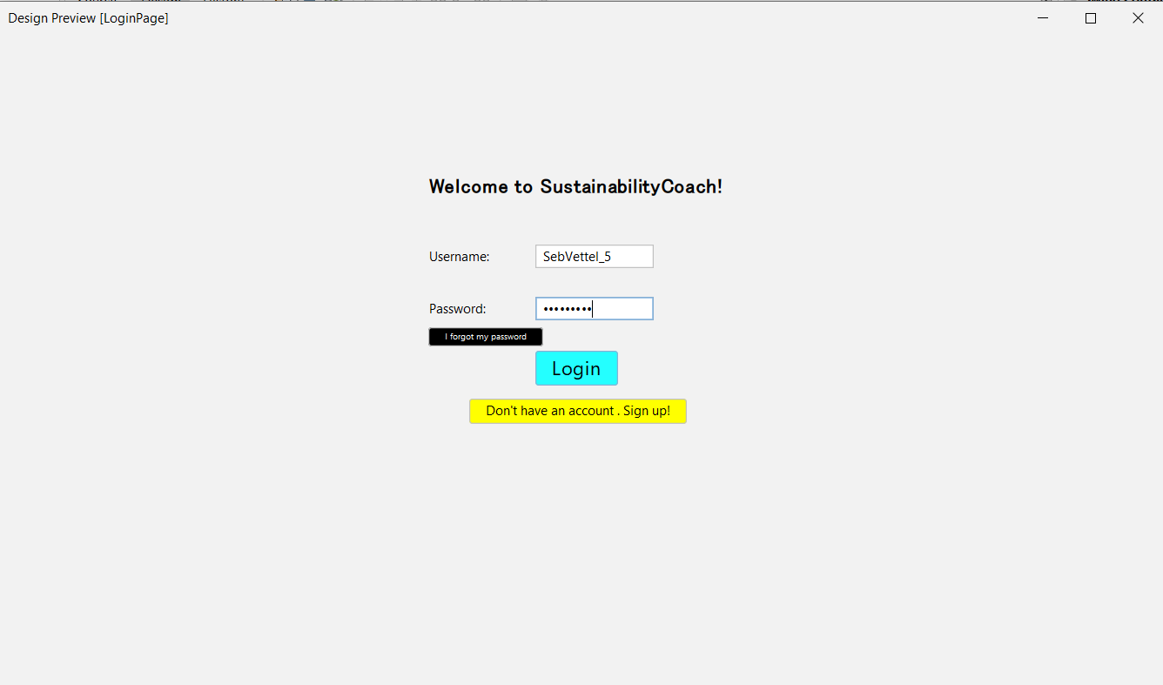

Figure 1

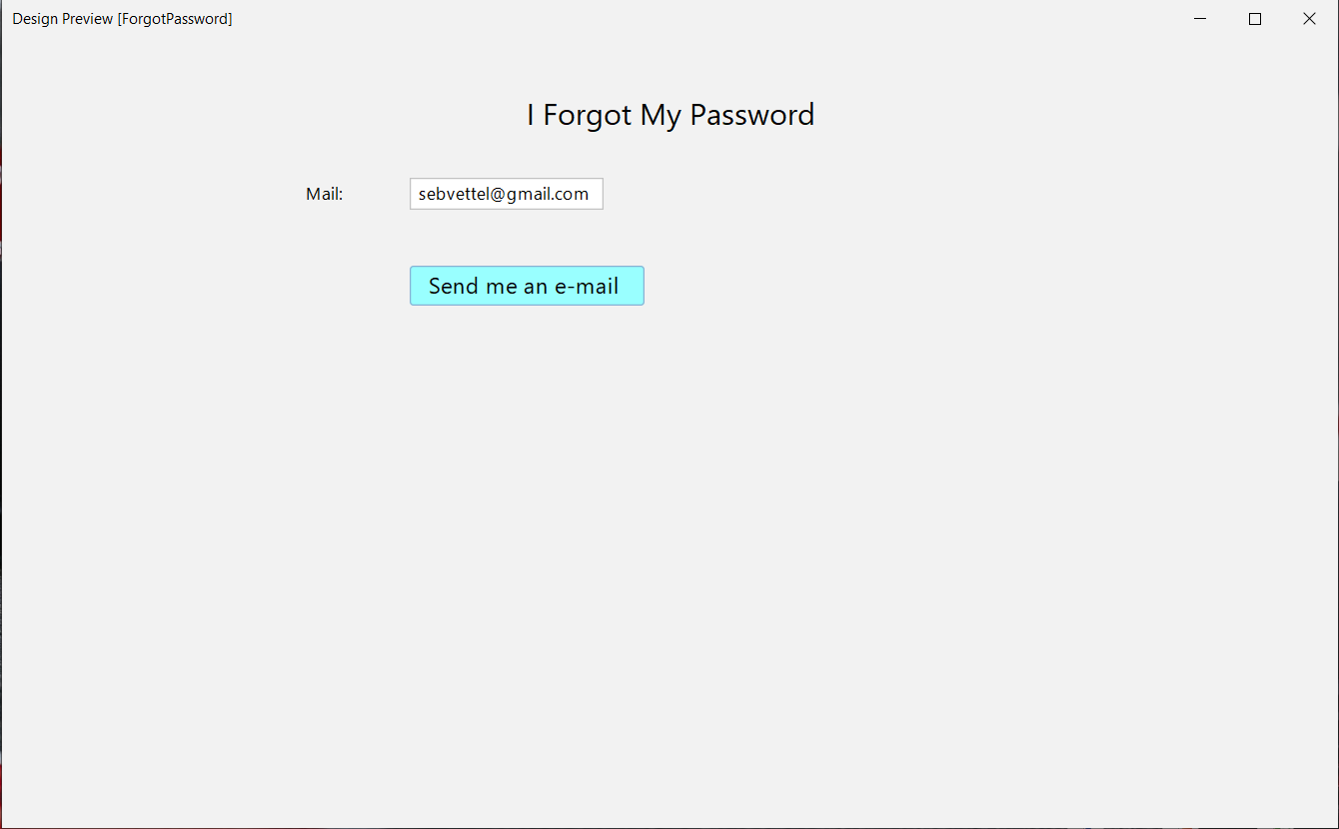

Figure 2

Figure 3

## Achievements

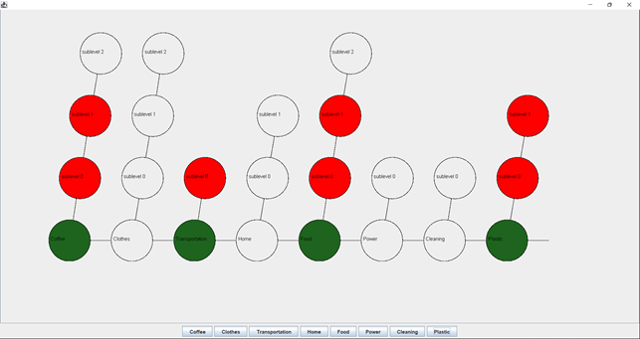

Figure 4

The tree in figure 4 is deawn for every user. A closer image is shown in figure 6. When the user creats their account, the questionare in the figure 5 is prompted to the user. After the user answers them, the custom tree is drawn. All possible tasks are listed in the table 1. Some tasks are default, meaning they are prompted to the every user. Others are promped if the user selected yes for the spesific question releted to that task. In the table, condition for every task is written in pharantesis next to the task. Therefore, the length and width of the tree changes for every user.



Figure 5

|  |  |
| --- | --- |
| **Category** | **TASK** |
| **Beverage** | * I used thermos in the coffee shop. (User drinks coffee.) * I made my own coffee instead of purchasing. (User drinks coffee.) * I brewed my tea in my pot instead of using tea-bag. (User drinks tea.) * I did not buy canned drinks. (User drinks canned drinks.) |
| **Clothes** | * I reduced my shopping frequency for new clothes. (Default.) * I bought second hand clothes. (Default.) * I bought clothes from local producer. (Default.) |
| **Transportatıon** | * I used public transportation instead of personal vehicle. (User has personal vehicle.) * I did not prefer plane. (User frequently uses plane.) * I walked instead of using transportation. (Default.) |
| **Home** | * I sorted out my garbage. (Default.) * I did not pour reminder oil into the sink. (User cooks.) |
| **Food** | * I purchase local vegetables/fruits. (Default.) * I ate vegetables and fruits when it is their season. (Default.) * I reduced my meat consumption. (User eats meat.) |
| **Power** | * I replaced my bulbs with energy saving ones. (Default.) * I invested in renewable energy companies. (User is interested in investment.) * I got automatic heating system. (User has their own house.) * I got water purifier system. (Default.) * I took my water bottle when I got out. (Default.) |
| **Cleanıng** | * I did not use detergent. (Default.) * I did not use softener. (Default.) * I invest in personal care companies that have policies for sustainability. (User is interested in investment.) * I used washable sanitary pad. (User is woman.) * I used washable diaper for my baby. (User has a baby.) |
| **Plastıc** | * I did not use plastic bag. (Default.) * I used paper cup or glass bottle instead of plastic ones. (User frequently orders food.) * I did not use plastic spoon or fork when I order food. (User frequently orders food.) |

Table 1

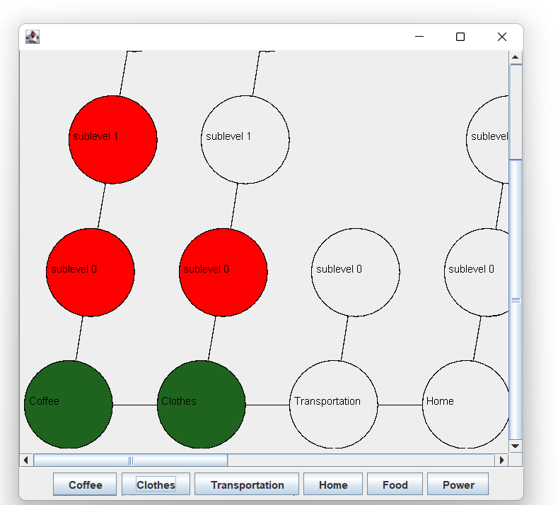

Figure 6

When the user clicks on one of the buttons below in figure 6, a window similar to one in figure 7 pops up. The user clicks on the “I completed the task” toggle button and the achievement is highlighted with a color change in the tree and a badge is given to the user displayed in figure 8. The message user added is shared in a list of messages in figure 9.

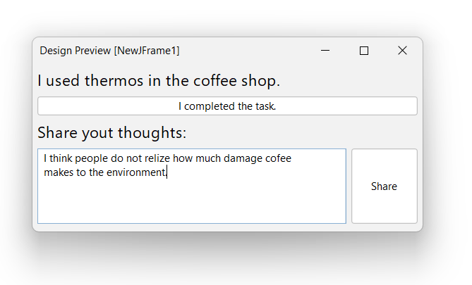

Figure 7

Survey Questions

* Do you drink coffee?
* Do you drink tea?
* Do you frequently buy canned beverages?
* Do you have personal car, motor cycle or other motor vehicle?
* Do you frequently use plane?
* Do you cook?
* Do you eat meat?
* Are you interested in investment?
* Do you have your own house?
* Do you have a baby?
* Do you frequently order food?

## Profile

In the profile section, intuitively, the player will be able to output their essential variables contained in the system, Sustainability Coach. Before describing the details, let’s have an example of the previous US president Donald Trump in Figure 6. On the leftmost part of our Java application in the profile section, to the corresponding section users will be able upload any part of their chosen avatar to be displayed on their specific parts in forum or the special badges created for the players. On the rightmost corner date will be shown. Notice that Datum corresponds to Date. In the coach tips section, players will be able to view daily tips for becoming more sustainable. This may be changed when the player runs re-run command by clicking to the dialogue box. In the information section, the players will be able view their in-game parameters such as scores and other labels designating specific aspects for them. The user will be able to update those by clicking & editing triggering the designated event listeners. Finally on the badges part, recent three of the achievements can be seen. Depending on the amount, the players will be able to extend this window to view all their trophies, if the amount exceeds the screen limit. Profile page is the page where the players will learn and edit their data (input) for the application to generate content (output). Once the player clicks on the awards, they will be able to see a summary of why they have been granted this reward. In the news page, the top players will be listed. Once clicked, the user will be able to see the top players profile page. Note that, only the top five players will be visible and accessible from the news page. The players can change their profile photo when they click on it and upload an image. Initially, there will be a default profile picture for all players.

Figure 8

## App News

In the news tab of the application, user will be able to see news about the application. On the top of the page, there will be “Breaking News” panel and user will see the most important news created by the application (Admins can manage this). Under “Breaking News”, important and featured news will be listed, such as the highest-ranking players and other special rankings. Additionally, We would like to use GPT-3 to be a companion in the application.

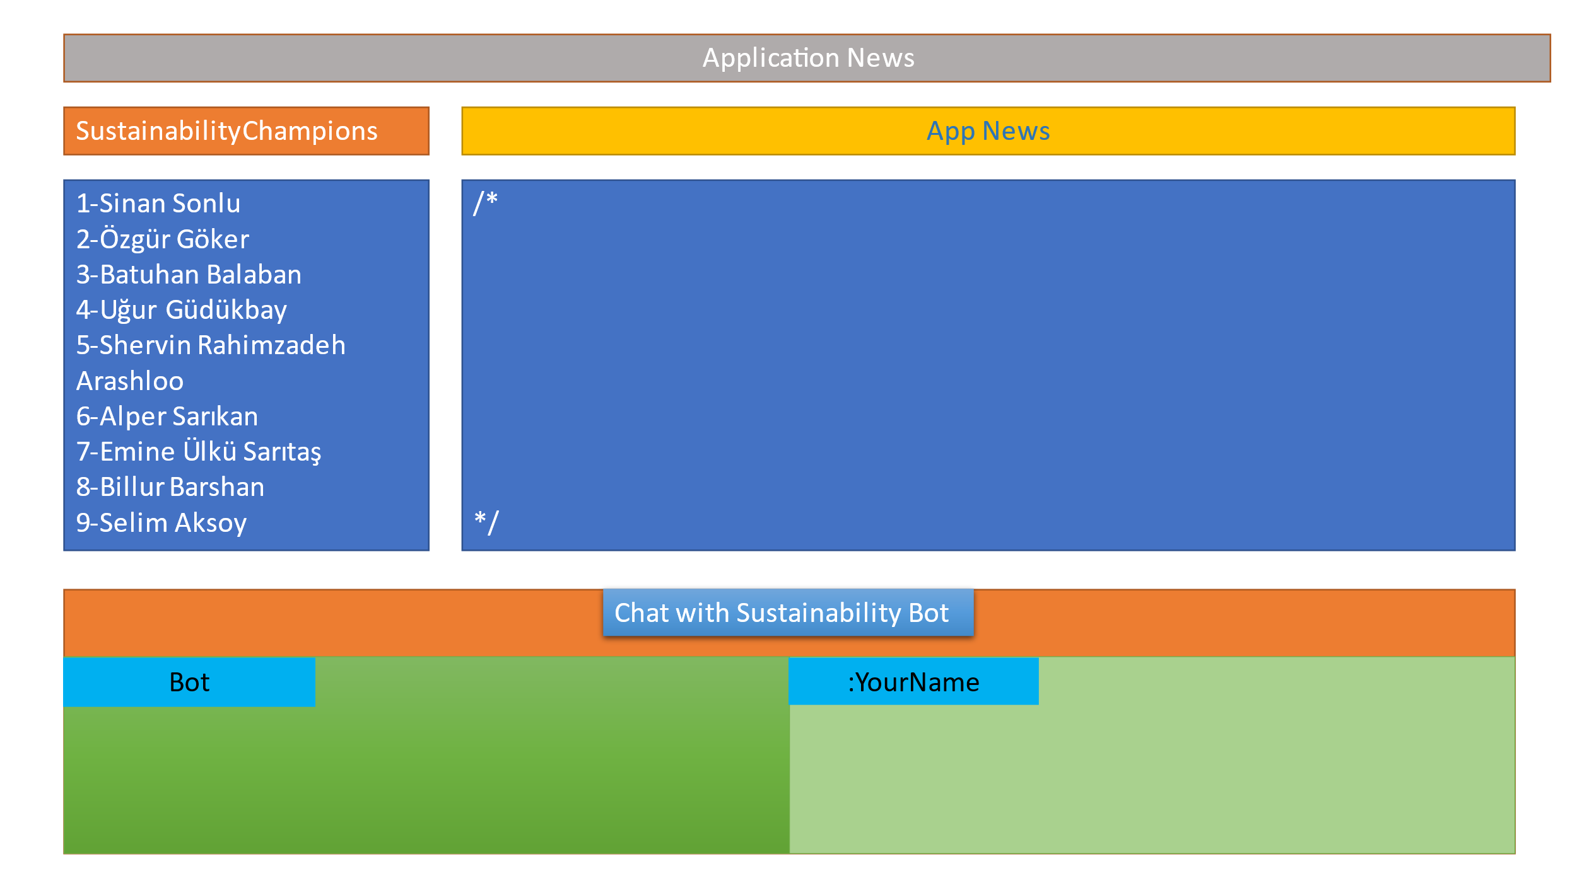

Figure 9

# Site Map

Figure 10

**Sign In:** Inputs Name and Password; Loads Data from Database and forwards to Achievements page. No menu is displayed.

**Forget Password:** To reset password. Can return to sign in. No menu is displayed.

**Register:** Creates a player object. Can return to sign in. No menu is displayed.

**Achievements:** The place where players will load data into the application. Main navigation menu is displayed at the top. Players will select missions which will launch pop-ups.

**Level Pop-Ups:** Special missions curated by the admins and the system.

**News:** The place where app news are displayed with the top (or five) ten ranked players. Chat-bot will be developed if necessary here. Main navigation menu is displayed at the top.

**Ranked Profile:** Same as the profile page, except unchangeable content and views the ranked profile.

**Profile:** Basic player info displayed here. The players when interreact with the text-fields will be able to change their information. Profile photo (A default profile photo initially) could be changed on click and upload.

**Menu:** Main navigation menu enables navigating between: Achievements, News, Profile and Exit.

//No settings page will be set for the players. Admins may be able to change it from the code.

# Conclusion

To conclude Sustainability Coach is an app that has many valuable features. It encourages people act on important issues. It inspires people to work on themselves and changes their lifestyle for a better envoirment. It atractes user in a lots of different ways: gamification, bagdes, social status, etc.

One of the world's critical problems could be resolved by the Sustainability Coach. It accomplishes this through enhancing the joy and significance of people's lives. Therefore, our project will enable all of us to improve the planet and provide the chance to become the world's saviors.

# Citations

* “What Is Gamification? Examples and Best Practices in ELearning.” *Valamis*, https://www.valamis.com/hub/gamification.
* “Sustainability.” *KTH*, https://www.kth.se/is/mst/sustainability.
* “Sustainable Habits - Change Daily Habits to Protect the Planet.” *Sustainablehabits*, https://www.sustainablehabits.org/.
* “50 Critical Sustainable Habits to Add to Your Everyday Life.” *Polly Barks*, Polly Barks, 26 Feb. 2021, https://pollybarks.com/blog/sustainable-habits.
* “Bilkent Declares 2021–2022 'Sustainability Year'.” *EN Bilkent University*, https://w3.bilkent.edu.tr/bilkent/bilkent-declares-2021-2022-sustainability-year/.
* “Sustainability at the Annual Meeting in Davos.” *World Economic Forum*, https://www.weforum.org/sustainability-world-economic-forum/sustainability-at-davos.
* “Why Sustainability Was the Star at Davos 2020.” *Forbes*, Forbes Magazine, 30 Jan. 2020, https://www.forbes.com/sites/lbsbusinessstrategyreview/2020/01/29/why-sustainability-was-the-star-at-davos-2020/?sh=45a49b5576a3.
* *Duolingo*. Duolingo. [Duolingo - The world's best way to learn a language](https://www.duolingo.com/)
* *Dr Wolf.* Chess.com, LLC*.* [Learn Chess with Dr Wolf on the App Store (apple.com)](https://apps.apple.com/us/app/learn-chess-with-dr-wolf/id1353041020)
* *Fabulous: Daily Habit Tracker.* Fabulous*.* [Fabulous: Daily Habit Tracker on the App Store (apple.com)](https://apps.apple.com/ua/app/fabulous-daily-routine-planner/id1203637303)